PORTFOLIO DOCUMENTAION:

Created the AWS free trail account .
Created Databricks free edition account .

Under AWS services :
Created a bucket shree-b1(enabled bucket versioning) which includes 4 folders :
- RAW
- BRONZE
- SILVER
- GOLD

Uploaded e commerce csv file inside raw folder and gave permissions to access this bucket .
By using below code gave read only access for s3 from databricks.

BUCKET POLICY FOR S3 FOR CONNECTING TO DATABRICKS :

{
"Version": "2012-10-17",
"Statement": [
{
"Sid": "PublicReadOnly",
"Effect": "Allow",
"Principal": "*",
"Action": "s3:GetObject",
"Resource": "arn:aws:s3:::shree-b1/raw/*"
}
]
}

USING IAM SERVICES :
Created one user ‘shree’ , with password . logged in to AWS console using new user shree and password.
Under security credentials of this user , created access key and secret key and downloaded it csv format.
For user shree gave certain access/polices like
S3 full access.
Glue full access.
Lambda full access.

CREATED group Data_engineer under IAM user groups , gave certain access and added user shree to this group.

CONNECTING AWS S3 BUCKET TO DATABRICKS :
OPTION 1 (✅ BEST PRACTICE): Attach IAM Role at Databricks Workspace Level
👉 Recommended for production & exams
This makes the role available to all clusters in the workspace.

Step 1: Create an IAM Role in AWS
- Go to AWS Console → IAM → Roles → Create role
- Trusted entity:
  - Choose AWS account
  - Enter Databricks AWS Account ID (Databricks provides this in docs)
- Attach S3 policy (example):
{
"Version": "2012-10-17",
"Statement": [
{
"Effect": "Allow",
"Action": [
"s3:ListBucket",
"s3:GetObject",
"s3:PutObject"
],
"Resource": [
"arn:aws:s3:::shree-b1",
"arn:aws:s3:::shree-b1/*"
]
}
]
}
- Name the role, e.g.
databricks-s3-access-role

Step 2: Register the Role in Databricks (Instance Profile)
- In Databricks Workspace
- Go to Admin Settings → Advanced → Instance Profiles
- Click Add Instance Profile
- Paste the IAM Role ARN:
arn:aws:iam::<account-id>:role/databricks-s3-access-role
- Save ✔️

Step 3: Use the Role in Clusters
- Create or edit a cluster
- Under Advanced Options → Instance Profile
- Select:
databricks-s3-access-role
- Start cluster

Step 4: Test Access
dbutils.fs.ls("s3://shree-b1/")
✅ Works without keys
✅ Secure
✅ Production-ready
NOTE :
❌ What NOT to do (important for interviews & real jobs)
❌ Bad Practice | Why
Hardcoding AWS keys in notebooks | Security violation
spark.conf.set() for secrets | Blocked by Databricks
Using s3a:// without credentials | Falls back to Anonymous
Committing keys to GitHub | Career-ending mistake

Since I have used Databricks free edition and AWS free trail account , so above method is not feasible .I have added bucket policy under S3 bucket for read only . by using below code I accessed the csv file present inside the S3 bucket .
If the S3 bucket is public, you can read it:
spark.read.csv("s3a://public-bucket-name/file.csv", header=True)
But:
- No write access
- Not suitable for real projects
- Only for demos

NOTE :
In Databricks on AWS, S3 access should be provided using IAM roles and instance profiles instead of access keys.”

SETTING UP THE AUTOLOADER STREAM/BACTH :
spark.conf.set(
"spark.databricks.cloudFiles.formatValidation.enabled",
"false"
)

Implementing autoloader in databricks
source_path = "s3a://shree-b1/raw/"

# checkpoint_path = "dbfs:/tmp/checkpoints/ecommerce_autoloader/"
# target_path = "dbfs:/tmp/delta/ecommerce_raw/"

Creating auto-loader stream
df = (
spark.read
.format("cloudFiles")
.option("cloudFiles.format", "json")
.option("cloudFiles.inferColumnTypes", "true")
.load(source_path)
)

Writing stream to delta table
query = (
df.writeStream
.format("delta")
.outputMode("append")
.option("checkpointLocation", checkpoint_path + "data")
.start(target_path)
)

WORKING INCREMENTAL INGESTION PATTERN

df = spark.read \
.option("inferSchema", "true") \
.json("s3a://shree-b1/raw/")

from pyspark.sql.functions import current_timestamp, input_file_name

from pyspark.sql.functions import current_timestamp, col

df_enriched = (
df
.withColumn("ingestion_time", current_timestamp())
.withColumn("source_file", col("_metadata.file_path"))
)

df_enriched.write \
.mode("append") \
.parquet("/Volumes/workspace/default/shree_project")

spark.read.parquet("/Volumes/workspace/default/shree_project").show()

existing_files = (
spark.read.parquet("/Volumes/workspace/default/shree_project")
.select("source_file")
.distinct()
)

new_data = df_enriched.join(
existing_files,
on="source_file",
how="left_anti"
)

new_data.write \
.mode("append") \
.parquet("/Volumes/workspace/default/shree_project")

SINCE I WAS USING AWS FREE TRAIL AND DATABRICKS FREE EDITION , Incremental loading / Auto loader was not supporting .
✅ FINAL VERIFIED BEHAVIOR (Databricks Free Edition – 2025)
You are correct:
ONLY Volumes are writable in Databricks Free Edition
Everything else is blocked, including:
- ❌ /databricks/driver
- ❌ /tmp
- ❌ dbfs:/
- ❌ Delta tables
- ❌ Streaming sinks
- ❌ Checkpoints
So when you say:
“only volume thing is supporting”

1️⃣ Architecture & Storage
- AWS S3 as external source (Bronze)
- Databricks Volumes as managed storage
- Clear Bronze → Silver → Gold layering
- JSON → Parquet → Delta
2️⃣ Data Engineering
- Deduplication
- Null handling
- Date formatting
- Schema standardization
- Star schema (Fact + Dimensions)
3️⃣ Slowly Changing Dimension (Type 2)
- effective_from, effective_to, is_current
- Old record expiry + new version insert
- Validation via controlled data change (Bangalore → Mysore)
4️⃣ Orchestration
- 4 separate notebooks (clean separation of concerns)
- Job dependencies:
- Ingestion → Star Schema → Implement SCD → Validate SCD
- Job run success, timeline, graph view

ARCHITECTURE :

AWS S3 (Raw JSON)
↓
Databricks Bronze (Read-only)
↓
Silver Layer (Cleaned Parquet - Volumes)
↓
Gold Layer (Aggregated Business Tables)
↓
Power BI / Analytics

Medallion Architecture:
Databases/APIs/LOGS/Events -> bronze -> Silver-> Gold ->BI/ML

BRONZE /Raw ingestion:(Used for reprocessing and recovery)
Raw, unprocessed data
Append only
Schema may change
Exact copy of source data

Silver Layer: Clean and refined
Cleaned and validated
Deduplicated records
Standardized formats.
Business logic applied
Joins and enrichments

GOLD LAYER: Analytics ready. (Built for decision making)
Aggregated data
Business-level metrics
Start Schemas
Optimized for Querying

BRONZE: DATA ENGINEERS
SILVER: ANALYTICS ENGINEER AND DATA SCIENTISTS
GOLD: ANALYTICS AND BUSINESS USERS.

STEP 1 :Reading the data from S3 buckets(RAW bucket )
Customer= spark.read.option("inferSchema", "true").json("s3://e-commerce-shree/customers_500.json", multiLine=True)
Orders= spark.read.option("inferSchema", "true").json("s3://e-commerce-shree/orders_500.json", multiLine=True)
Payments = spark.read.option("inferSchema", "true").json("s3://e-commerce-shree/payments_500.json", multiLine=True)
Products= spark.read.option("inferSchema", "true").json("s3://e-commerce-shree/products_500.json", multiLine=True)

Since I was not able to write back to S3 , I created One volume shree_project under
Path workspace/default/shree_project .

Inside shree_project volume , I created 3 folders/directories
BRONZE
SILVER
GOLD .
I uploaded/wrote the data read from s3 raw to BRONZE folder inside the volume.

Writing the data to bronze layer(bronze folder inside Volumes)
Customer.write.mode("overwrite").json("/Volumes/workspace/default/shree_project/bronze/customers")
Orders.write.mode("overwrite").json("/Volumes/workspace/default/shree_project/bronze/orders")
Payments.write.mode("overwrite").json("/Volumes/workspace/default/shree_project/bronze/payments")
Products.write.mode("overwrite").json("/Volumes/workspace/default/shree_project/bronze/products")

Step 2: Performed transformations using pyspark on BRONZE layer data.
import pyspark
from pyspark.sql import SparkSession
from pyspark.sql.functions import *
from pyspark.sql.types import *
from pyspark.sql.window import Window

# df.createOrReplaceTempView("sample")
# spark.sql("select * from sample where order_id=1001").show()
print("====================================================================================================")
Customer.show()

Customer_new=Customer.dropDuplicates(['customer_id']);
Customer_new.show()

c2=Customer_new.withColumn("signup_date",col('signup_date').cast('date'))
c2.printSchema()
cust_final=c2.withColumn("signup_date",date_format(col("signup_date"),"dd-MM-yyyy"))
cust_final.show()

print("====================================================================================================")
Orders.show()
Orders.printSchema()
Orders.select("customer_id").distinct().show()
ord_final=Orders.filter(col('customer_id')!='null')
ord_final.show()

# # required_cols = ["order_id", "customer_id", "product_id"]

# # o1 = Orders.dropna(subset=required_cols)

# # o1.show()
print("====================================================================================================")

Products.show()
Products.printSchema()
P1=Products.filter(col('product_name')!="null")
P2=P1.withColumn("price", col("price").cast("int"))
prod_final= P2.withColumn("price", round(col("price"), 0))
prod_final.show()

print("====================================================================================================")
Payments.show()
Payments.printSchema()
p1=Payments.withColumn("payment_date",col('payment_date').cast('date'))
p1.printSchema()
p2=p1.withColumn("payment_date",date_format(col("payment_date"),"dd-MM-yyyy"))
p3=p2.withColumn("amount",col('amount').cast('int'))
pay_final=p3.withColumn("amount",round(col('amount'),2))
pay_final.show()

Step 3: Writing the transformed data to Silver layer(volume) in parquet format
cust_final.write.mode("overwrite") \
.parquet("/Volumes/workspace/default/shree_project/silver/customers")

ord_final.write.mode("overwrite") \
.parquet("/Volumes/workspace/default/shree_project/silver/orders")

prod_final.write.mode("overwrite") \
.parquet("/Volumes/workspace/default/shree_project/silver/products")

pay_final.write.mode("overwrite") \
.parquet("/Volumes/workspace/default/shree_project/silver/payments")

Step 4: Data modeling (Converting cleaned data into star schema)

STAR SCHEMA FOR PROJECT
⭐ FACT TABLE
orders_fact
- One row per transaction
- Contains metrics (numbers)
⭐ DIMENSION TABLES
- customers_dim
- products_dim
- payments_dim

“I designed a star schema with orders as the fact table and customers, products, and payments as dimension tables. I defined the grain at order-product level and created dimension tables using deduplication. The fact table was built by joining dimensions and calculating business metrics like order_amount.”

Implementation:
CREATING DIMENSION TABLE:
import pyspark
from pyspark.sql import SparkSession
from pyspark.sql.functions import *
from pyspark.sql.types import *
from pyspark.sql.window import Window

customer_df=spark.read.parquet("/Volumes/workspace/default/shree_project/silver/customers")
order_df=spark.read.parquet("/Volumes/workspace/default/shree_project/silver/orders")
product_df=spark.read.parquet("/Volumes/workspace/default/shree_project/silver/products")
payment_df=spark.read.parquet("/Volumes/workspace/default/shree_project/silver/payments")

customer_df.show()
product_df.show()
payment_df.show()

customer_dim=(
customer_df.dropDuplicates(['customer_id'])
.filter(col('customer_id').isNotNull())
)

customer_dim.write.mode("overwrite")\
.parquet("/Volumes/workspace/default/shree_project/gold/customer_dim")

product_dim=(
product_df.dropDuplicates(['product_id'])\
.filter(col('product_id').isNotNull())

)

product_dim.write.mode("overwrite")\
.parquet("/Volumes/workspace/default/shree_project/gold/product_dim")

payment_dim=(
payment_df.dropDuplicates(['payment_id'])\
.filter(col('order_id').isNotNull())
)

payment_dim.write.mode("overwrite")\
.parquet("/Volumes/workspace/default/shree_project/gold/payment_dim")

CREATING FACT TABLE :
order_fact= (
order_df.join(
customer_dim,"customer_id","inner")\
.join(product_dim,"product_id","inner")\
.select(

order_df.order_id,
order_df.order_date,
order_df.customer_id,
order_df.product_id,
order_df.quantity,
order_df.order_status,
product_dim.price.alias("unit_price"),
(order_df.quantity*product_dim.price).alias("order_amount")

)
)

WRITNG FACT TABLE TO GOLD LAYER/FOLDER :
order_fact.write.mode("overwrite")\
.parquet("/Volumes/workspace/default/shree_project/gold/order_fact")

/Volumes/workspace/default/shree_project/gold
├── customers_dim
├── products_dim
├── payments_dim
└── orders_fact

“After cleaning data in the Silver layer, I modeled it into a star schema with fact and dimension tables, which formed the Gold layer. These tables were optimized for analytics and consumed by BI tools.”

STEP 5:
Reading customer table from silver layer and adding surrogate keys to implement SCD-2
“Before applying SCD Type-2 MERGE, I initialized the dimension table with surrogate keys and SCD control columns like effective_from, effective_to, and is_current. This allowed Delta MERGE to correctly manage historical versions.”

IMPLEMENTATION:
from pyspark.sql.functions import lit, current_date

silver_customer = (
spark.read.parquet("/Volumes/workspace/default/shree_project/silver/customers")
.dropDuplicates(["customer_id"])
)

customer_dim = (
silver_customer
.withColumn("effective_from", current_date())
.withColumn("effective_to", lit(None).cast("date"))
.withColumn("is_current", lit(True))
)

customer_dim.write \
.format("delta") \
.mode("overwrite") \
.save("/Volumes/workspace/default/shree_project/gold/customer_dim_delta")

from delta.tables import DeltaTable

customer_delta = DeltaTable.forPath(
spark,
"/Volumes/workspace/default/shree_project/gold/customer_dim_delta"
)

incoming = (
spark.read.parquet("/Volumes/workspace/default/shree_project/silver/customers")
.dropDuplicates(["customer_id"])
)

STEP 6: IMPLEMENTING SCD 2(CUSTOMER_TABLE) AND MERGE (IN DELTA FORMAT)
I implemented SCD Type-2 on the customer dimension using Delta MERGE. The merge condition tracks changes on descriptive attributes like name, email, phone, and location, while keeping stable attributes untouched. Historical versions are maintained using effective dates and a current flag.”
IMPLEMENTATION:
SCD MERGE:
customer_delta.alias("t") \
.merge(
incoming.alias("s"),
"t.customer_id = s.customer_id AND t.is_current = true"
) \
.whenMatchedUpdate(
condition="""
t.name <> s.name OR
t.email <> s.email OR
t.phone <> s.phone OR
t.city <> s.city OR
t.state <> s.state
""",
set={
"is_current": "false",
"effective_to": "current_date()"
}
) \
.whenNotMatchedInsert(
values={
"customer_id": "s.customer_id",
"name": "s.name",
"email": "s.email",
"phone": "s.phone",
"city": "s.city",
"state": "s.state",
"signup_date": "s.signup_date",
"effective_from": "current_date()",
"effective_to": "null",
"is_current": "true"
}
) \
.execute()

VALIDATING SCD 2 :
spark.read.format("delta")\
.load("/Volumes/workspace/default/shree_project/gold/customer_dim_delta")\
.orderBy("customer_id","effective_from")\
.show(truncate=False)

Since the data is not changed so the column effective_to is set null and is_current is set to true.

CHANGING THE SILVER DATA:
Updating the customer city to manglore for customer_id C001.
from pyspark.sql.functions import *

# silver_path = "/Volumes/workspace/default/shree_project/silver/customers/"

silver_df=spark.read.parquet("/Volumes/workspace/default/shree_project/silver/customers/")

silver_updated=silver_df.withColumn("city",
when(col('customer_id')=='C001','mysore')\
.otherwise(col('city'))
)

silver_updated.write.mode("overwrite").parquet("/Volumes/workspace/default/shree_project/silver/customers/")

AGAIN WE NEED TO RE RUN THE SCD – 2 LOGIC :

from delta.tables import DeltaTable
customer_delta = DeltaTable.forPath(
spark,
"/Volumes/workspace/default/shree_project/gold/customer_dim_delta"
)

incoming = (
spark.read.parquet("/Volumes/workspace/default/shree_project/silver/customers")
.dropDuplicates(["customer_id"])
)
customer_delta.alias("t") \
.merge(
incoming.alias("s"),
"t.customer_id = s.customer_id AND t.is_current = true"
) \
.whenMatchedUpdate(
condition="""
t.name <> s.name OR
t.email <> s.email OR
t.phone <> s.phone OR
t.city <> s.city OR
t.state <> s.state
""",
set={
"is_current": "false",
"effective_to": "current_date()"
}
) \
.whenNotMatchedInsert(
values={
"customer_id": "s.customer_id",
"name": "s.name",
"email": "s.email",
"phone": "s.phone",
"city": "s.city",
"state": "s.state",
"signup_date": "s.signup_date",
"effective_from": "current_date()",
"effective_to": "null",
"is_current": "true"
}
) \
.execute()

TO VERIFY THE CHANGED RECORD :
spark.read.format("delta") \
.load("/Volumes/workspace/default/shree_project/gold/customer_dim_delta") \
.filter(col("customer_id") == "C001") \
.orderBy("effective_from") \
.show(vertical=True)

OUTPUT:
-RECORD 0------------------------------
city | Bangalore
customer_id | C001
email | amit.sharma@gmail...
name | Amit Sharma
phone | 9876543210
signup_date | 15-01-2023
state | Karnataka
effective_from | 2026-02-19
effective_to | 2026-02-19
is_current | false
-RECORD 1------------------------------
city | mysore
customer_id | C001
email | amit.sharma@gmail...
name | Amit Sharma
phone | 9876543210
signup_date | 15-01-2023
state | Karnataka
effective_from | 2026-02-19
effective_to | NULL

Orchestration using Databricks Jobs:
🔄 Pipeline Orchestration (Databricks Jobs)
The end-to-end data pipeline is orchestrated using Databricks Jobs, where the workflow is divided into four modular notebooks executed in a defined dependency order. The job ensures reliable, sequential execution from ingestion to validation.
- Ingestion_and_transforming – Ingests raw JSON data from the Bronze layer and performs initial cleansing and transformations
- Star_schema – Builds fact and dimension tables in the Silver layer
- Implementing_SCD – Applies Slowly Changing Dimension (Type 2) logic and writes Delta tables to the Gold layer
- Validating_SCD – Validates historical versioning and current record flags
The job is executed on serverless compute, with task-level dependencies, execution timelines, and success/failure monitoring enabled to ensure end-to-end reliability and reusability of the pipeline.

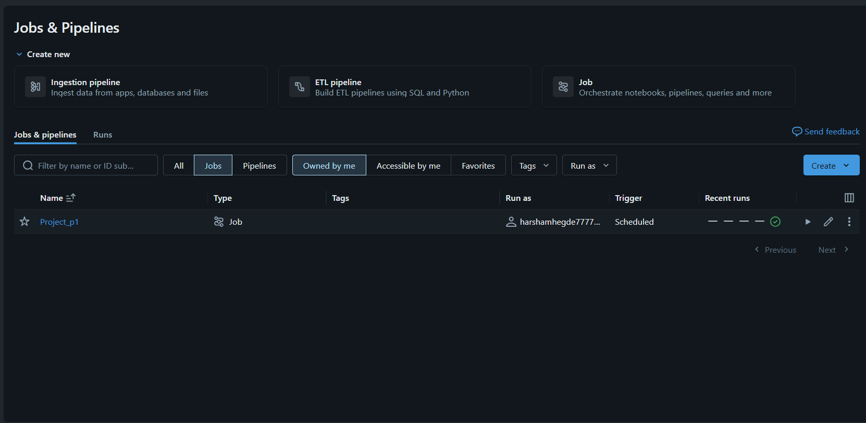
Snapshots:

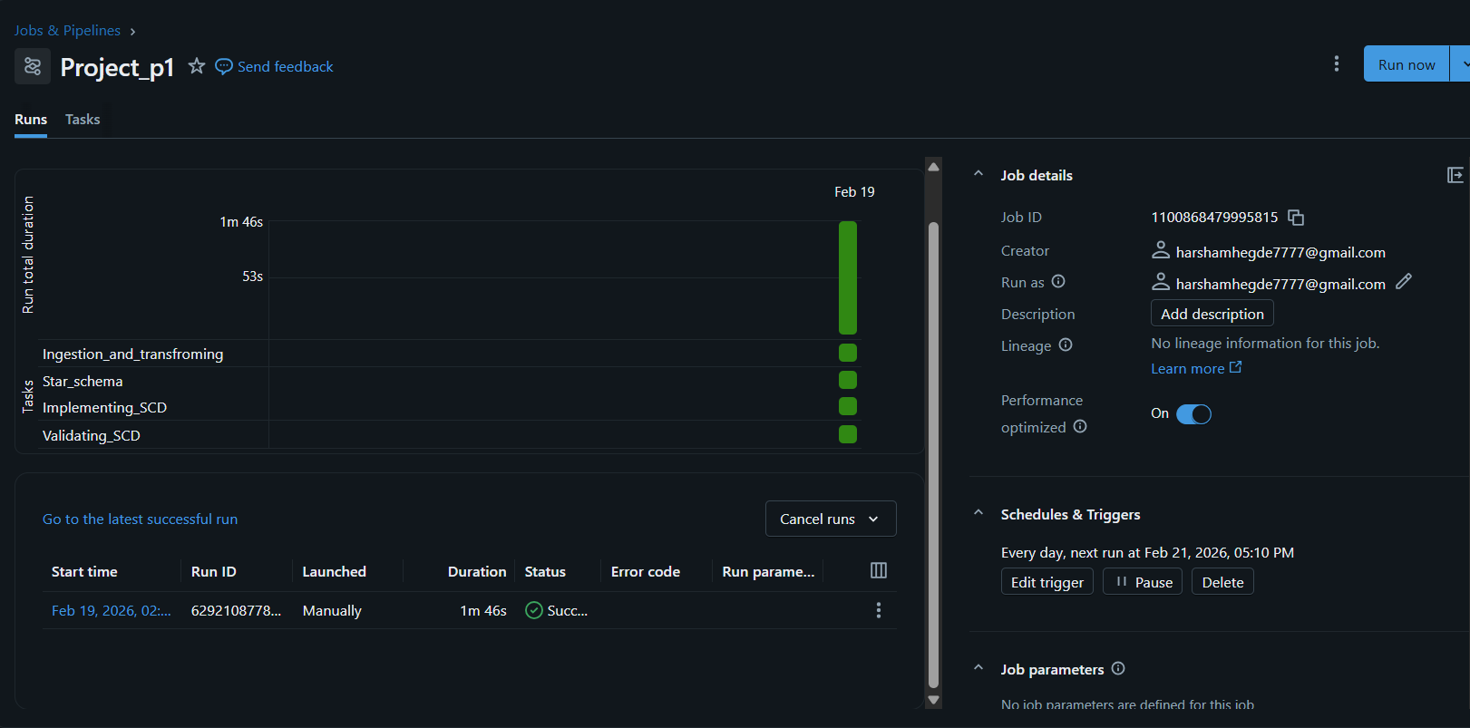
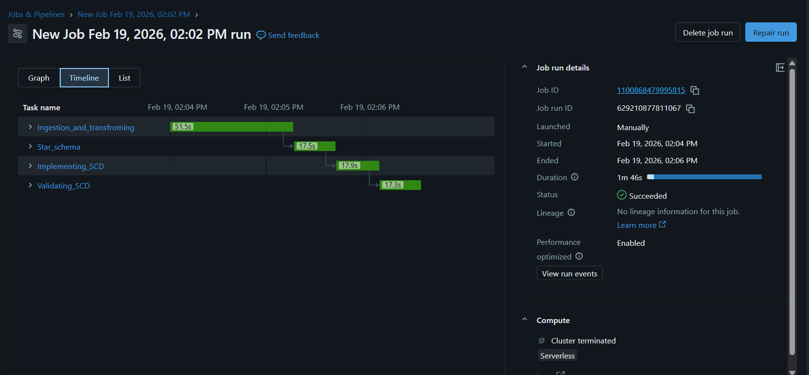
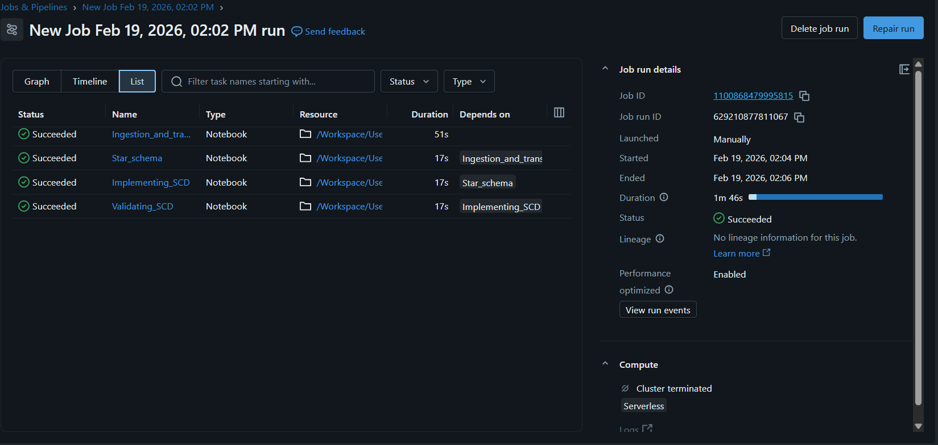

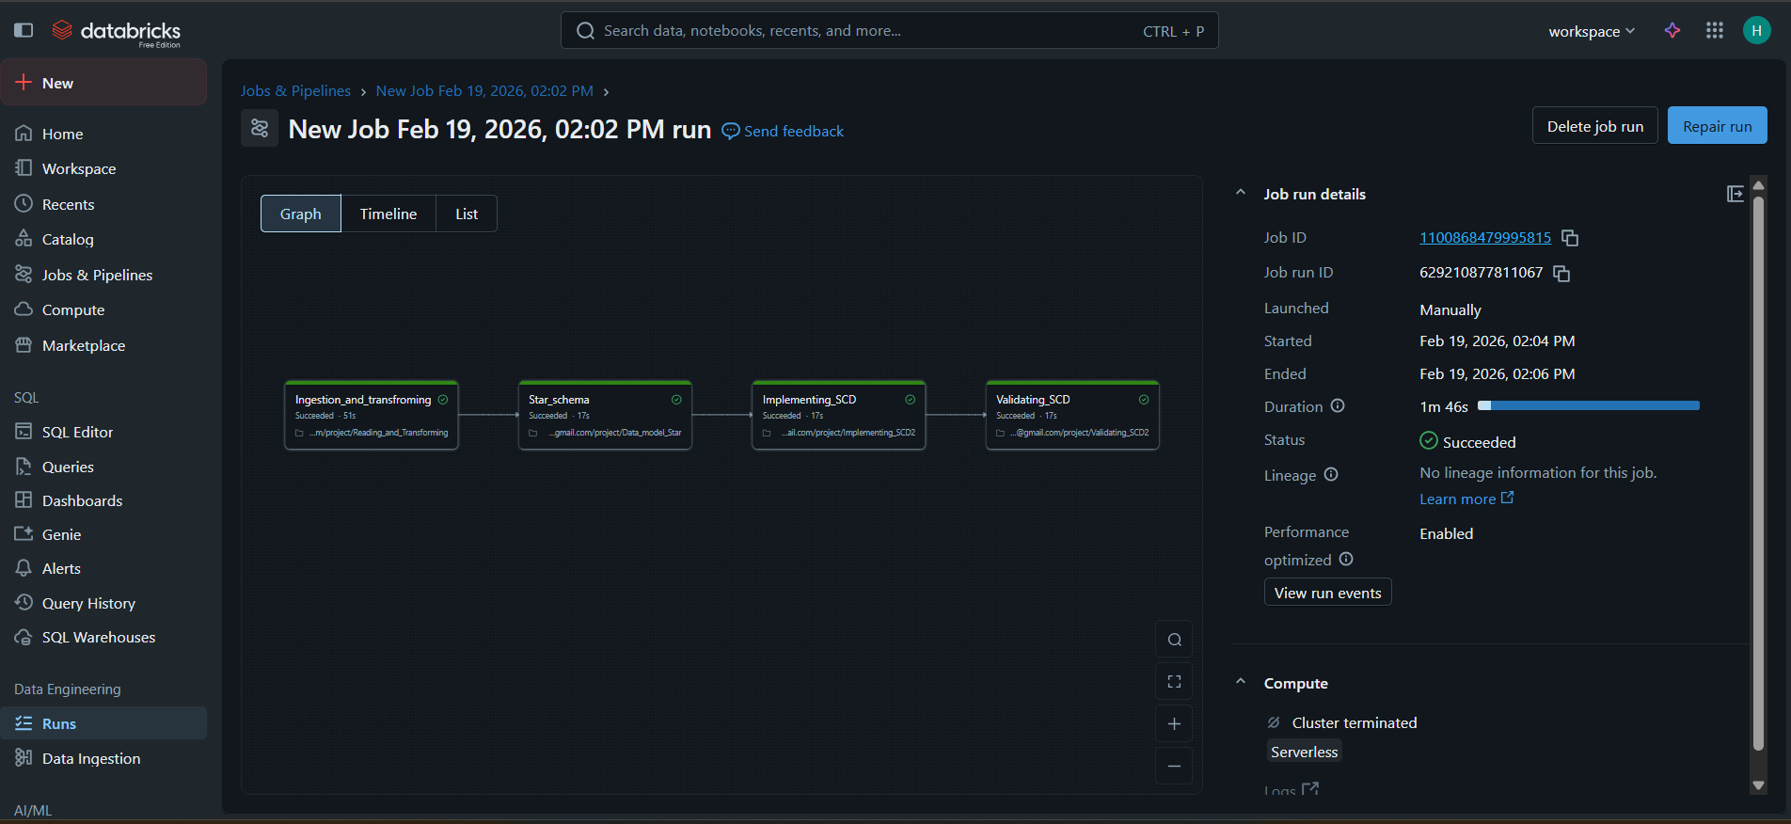

The pipeline is automated using Databricks Jobs and scheduled to run daily, executing ingestion, transformation, star schema modeling, and SCD Type 2 processing to maintain up-to-date and historically accurate analytical datasets.

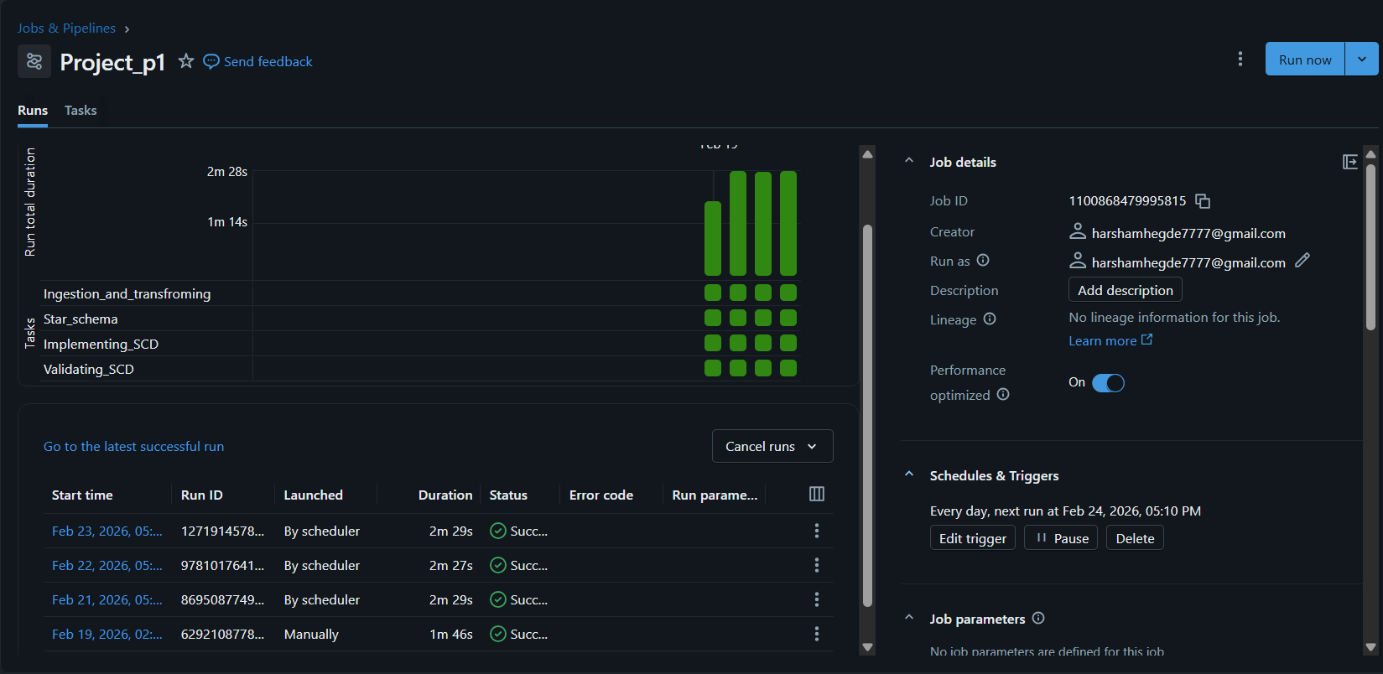

GENERATING REPORTS:(daily, weekly, monthly)
from datetime import date, timedelta
from pyspark.sql.functions import col, count, sum as _sum

dbutils.widgets.dropdown(
"time_period",
"daily",
["daily", "weekly", "monthly"]
)

time_period = dbutils.widgets.get("time_period")
report_date = date(2024, 12, 12)
if time_period == "daily":
start_date = report_date - timedelta(days=1)
end_date = start_date

elif time_period == "weekly":
start_date = report_date - timedelta(days=report_date.weekday() + 7)
end_date = start_date + timedelta(days=6)

elif time_period == "monthly":
first_day_current_month = report_date.replace(day=1)
end_date = first_day_current_month - timedelta(days=1)
start_date = end_date.replace(day=1)

orders_df = spark.read.parquet(
"/Volumes/workspace/default/shree_project/silver/orders"
)

customers_df = spark.read.parquet(
"/Volumes/workspace/default/shree_project/silver/customers"
)

report_df = (
orders_df
.join(customers_df, "customer_id", "inner")
.filter(
(col("order_date") >= start_date) &
(col("order_date") <= end_date)
)
.groupBy("city")
.agg(
count("order_id").alias("total_orders"),
_sum("quantity").alias("total_quantity")
)
)

print(f"Report Type : {time_period.upper()}")
print(f"Data Range : {start_date} to {end_date}")

display(report_df)

Snapshot:

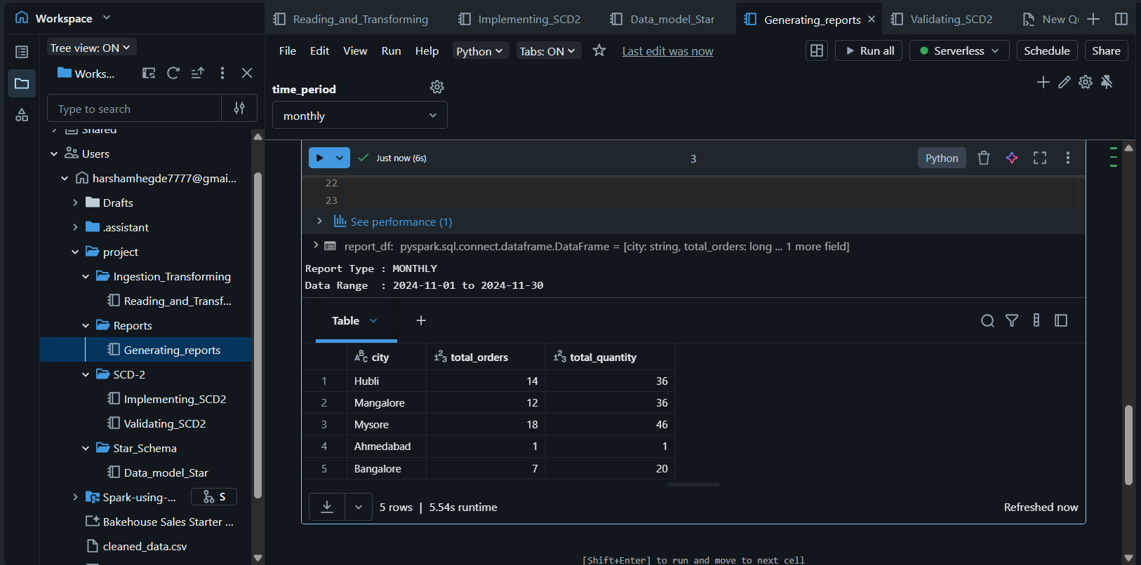

SQL Analytics:
Created 4 views based on 4 tables Customer, Orders, Payments and Products using Gold layer.
CREATE OR REPLACE VIEW vw_customers AS
SELECT *
FROM delta.`/Volumes/workspace/default/shree_project/gold/customer_dim_delta`
WHERE is_current = true;

CREATE OR REPLACE VIEW vw_orders AS
SELECT *
FROM delta.`/Volumes/workspace/default/shree_project/gold/order_fact`;

CREATE OR REPLACE VIEW vw_products AS
SELECT *
FROM delta.`/Volumes/workspace/default/shree_project/gold/product_dim`;

CREATE OR REPLACE VIEW vw_payments AS
SELECT *
FROM delta.`/Volumes/workspace/default/shree_project/gold/payment_dim`;

CACULATING REVENUE BY CITY USING SQL QUERY:
SELECT
c.city,
format_number(SUM(o.order_amount),0) AS total_revenue
FROM vw_orders o
JOIN vw_customers c
ON o.customer_id = c.customer_id
GROUP BY c.city;

ORDERS BY REVENUE CATEGORY:
SELECT
p.category,
COUNT(o.order_id) AS total_orders,
format_number(SUM(o.order_amount),0) AS revenue
FROM vw_orders o
JOIN vw_products p
ON o.product_id = p.product_id
GROUP BY p.category;

PAYMENTS STATUS SUMMARY:
SELECT
payment_status,
COUNT(*) AS total_payments
FROM vw_payments
GROUP BY payment_status;

DAILY ORDER TRENDS :
SELECT
payment_status,
COUNT(*) AS total_payments
FROM vw_paymentss
GROUP BY payment_status;

FUTURE WORKS :
1️⃣ Data Quality Checks
Right now you transform, but you don’t validate.
Add:
- Null checks on business keys
- Duplicate checks
- Referential integrity checks
Example (Silver → Gold gate)
from pyspark.sql.functions import col

invalid_customers = silver_customers.filter(
col("customer_id").isNull()
)

if invalid_customers.count() > 0:
raise Exception("Data quality failed: Null customer_id found")
👉 Interview keyword: “Data quality gate between Silver and Gold

2️⃣ Metadata & Audit Columns
Add these everywhere (especially Gold):
.withColumn("created_at", current_timestamp()) \
.withColumn("updated_at", current_timestamp()) \
.withColumn("source_system", lit("s3_bronze")) \
.withColumn("batch_id", lit("20240210"))
Interviewers LOVE hearing:
“We maintain audit columns for lineage and traceability.”
3️⃣ Surrogate Key–Based Fact Table Modeling
Extend the current star schema by using surrogate keys from dimension tables (customer_sk, product_sk, payment_sk) in the fact table instead of natural keys.
This aligns the model more closely with real-world data warehouse best practices.

4️⃣ Incremental Load Logic (Even Without Autoloader)
Since Autoloader is painful in Free Edition, simulate incremental loads:
- Track max order_date
- Filter new records only
max_date = fact_orders.select(max("order_date")).collect()[0][0]

new_orders = orders_silver.filter(col("order_date") > max_date)
Interview keyword:
“Incremental processing using watermark logic”

5️⃣ Business Metrics Table
Create a gold aggregate table:
daily_sales_summary
- date
- total_orders
- total_revenue
- unique_customers
This makes your pipeline business-ready.

CONCLUSION :
End-to-End Lakehouse Data Pipeline using AWS S3 and Databricks
- Designed and implemented a Bronze–Silver–Gold architecture
- Ingested semi-structured JSON data from AWS S3
- Applied data cleansing, deduplication, and schema standardization
- Built a star schema with fact and dimension tables
- Implemented Slowly Changing Dimension Type-2 using Delta Lake MERGE
- Orchestrated the pipeline using Databricks Jobs with task dependencies
- Validated historical tracking via controlled data changes
- Ensured reusability and modularity through notebook-based design

“I built an end-to-end lakehouse pipeline using AWS S3 and Databricks following the Medallion architecture.
Raw JSON data is ingested into Bronze, cleaned and standardized in Silver, and modeled into a Star Schema in Gold using Delta Lake.
I implemented SCD Type-2 for customer dimensions and MERGE logic, and validated historical changes.
The final Gold layer is analytics-ready and can be consumed by SQL or BI tools.”

